Erroneous Historical Classifications Leads To Misconception About The Cost Of Deflation

Zimo, GAO (20492168)

December 15 2020

**Abstract**

Since the 2008 financial crisis, central banks have issued policies with the risk of deflations. This paper utilized the economics data in the 19th century to estimate the average real activities during inflations and deflations. It is observed that the measurement errors in price indices cause the negative effect of deflations on the real economics activity growth to be underestimated. The true relationship between the economic growth and inflation (deflation) can be reproduced by jointly utilizing deflation indicators. The negative relationship can be found in the results of both the US and the UK.

**1 Introduction**

Whether deflations can cause a shortfall in the real economic activities has been a problem under debate, and it has been suggested by some previous works that deflations appear to be benign (Atkeson & Kehoe, 2004; Bordo & Filardo, 2005; Borio et al., 2015). This paper is a replication work of Daniel Kaufman’s (2019), which proposed measurements of the errors that existed in estimation of price indices and suggested that the negative effects of deflationary episodes had been underestimated in the previous research accordingly.

To obtain the cost of deflation, I first utilized a simple regression model taking only a binary inflation (deflation) indicator as the independent variable and real activity as the dependent variable. It can be observed that the simple OLS model may suffer from errors based on two reasons. First, the model may be erroneous if there is misclassification bias in the data relative to price index, since it will cause fallacy of the price index episodes and thus affect the estimation of real activity. Second, some of the inflation (deflation) episodes can be correlated with positive (negative) prediction errors on GDP deflator, and thus cause the negative (positive) estimation errors in the real GDP. These two potential errors will be the prime objective I attempted to resolve in this essay.

To fix the latent biases problems, I proposed two models. In the first model, I selected multiple error-ridden binary deflation indicators, which can address the problem of misreported data with the allowance for the measurement errors to be correlated. Moreover, I typically selected the data in US industrial production and the UK in the 19th century to ensure that the data is well-organized overall. From the regression result, it can be observed that the deflation can have a 2.1% negative effect on US industrial production growth if we assume that there are no measurement errors. However, if we utilized a second binary deflation indicator which assumes that there exists uncorrelated measurement errors, the negative effect will increase to 4.5%. If we utilize a model which also takes correlated measurement errors into consideration, the decline can be even greater (-7.6% effect).

Second, since it has long been argued that the price data in the 19th century is flawed, and multiple selections on the price indices have been addressed in the previous works (see, e.g., Margo, 2000; Cogley & Sargent, 2015), this paper in turns argues that all these price indices in the 19th century are imperfect, and they can be jointly utilized to enhance the measurement of economic growth in the periods of deflation. Moreover, this paper shows that erroneous measurements for the price indexes can lead to a regression result with missing shortfall with respect to economic growth during the periods of deflation.

**2 Data**

**2.1 CPI in the United States**

The CPI data is from Officer and Williamson (2016), which is highly precise and detailed. However, since the data utilized is for the 19th century and contains data pieces which are retrospective or being simulated with mathematical tools, it can sometimes be defective. For example, before 1939, the data records were restricted to a limited area in the US, which indicates the potential biased problems. Moreover, since the data is especially scarce between 1880 to 1890, some of the data is constructed with approximation and regressions.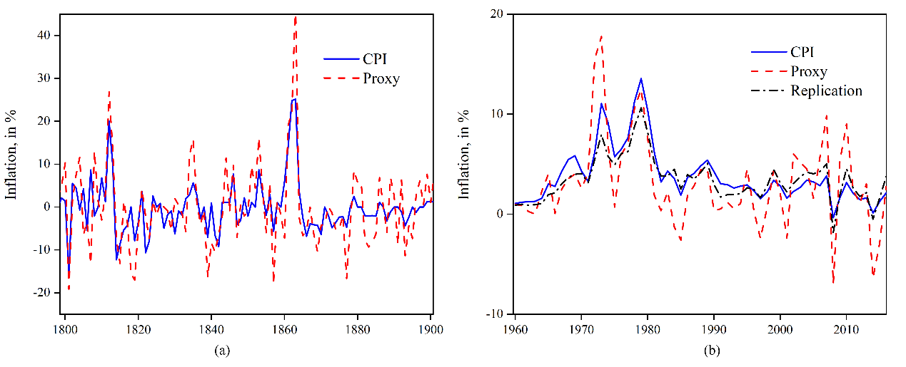

**Figure 1** CPI inflation, proxy, and modern replications.

**2.2 A new proxy for the United States**

A novel price index was constructed by Daniel (2019) which combines the price indices of 5 commodity groups by computing their expenditure weight average.This proxy leads to several major advantages. First, the high variety of data sources can help ensure that the measurement errors can be independent with the measurement errors in the CPI. Second, the misclassification bias can be reduced and the underlying data can be more accurate.

It can be observed from panel (a) in Figure 1 that the means of CPI and Proxy are identical at -0.2%, and they show similar trends as time series. Although the correlation is very high (0.74), they result in different classifications for 29% of the data points when differentiating inflation and deflation. Proxy displays a higher standard deviation (9.9) compared with the composite CPI (6.2).

**2.3 Misclassification rates for data in 20th century**

Since CPI and the proxy have similar data deficiencies, we infer that they may suffer from correlated measurement errors and thus violate the conditional independence assumption. To verify this inference, we utilized the data from 1960 to 2017 (Hoover, 1960) to replicate the proxy and CPI inflation’s retrospective estimation to obtain the joint misclassification rates, and I utilized the PPI data from the US bureau of Labor Statistics to construct the proxy for the post-WWII era. The result is shown in panel (b) of Figure 2. From the figure, it can be observed that proxy displays a more volatile growth than both the CPI and the replication result.

**Table 1** Misclassification rates

|  |  |  |  |  |  |  |  |  |
| --- | --- | --- | --- | --- | --- | --- | --- | --- |
|  | **Replication** | | **Proxy** | | **Product** | | **Joint** | |
|  | ***d*** = 1 | ***d*** = 0 | ***d*** = 1 | ***d*** = 0 | ***d*** = 1 | ***d*** = 0 | ***d*** = 1 | ***d*** = 0 |
| zero threshold | 0.000 | 0.018 | 0.000 | 0.125 | 0.000 | 0.002 | 0.000 | 0.018 |
| higher threshold | 0.216 | 0.200 | 0.270 | 0.400 | 0.058 | 0.080 | 0.108 | 0.200 |

To see whether the conditional independence assumption is violated, Table 1 displays the misclassification rates for replication and proxy. It can be observed that the replicated model never misclassified the deflations and has a very low misclassification rate for inflations. The proxy has a higher misclassification rate (12% for inflations).

If the indicators are conditionally independent, the result of the product panel should equal to the joint panel. We can observe that both the product and joint performs well with a very low misclassification rate. From the table, we can confirm that the misclassification bias can be reduced when jointly utilizing the information from both error-ridden indicators.

**2.4 Real activity data**

The real activity data for the US is from Davis (2004), which is estimated in real terms and can avoid being correlated with the measurement errors in price indices. The real activity data for the UK is from numerous sources to ensure the high quality of the data. The specific data sources can be seen in Table A.1 in Appendix.

**3 Analysis**

**3.1 Misclassification and deflator biases**

To know the robustness of real activity when price fluctuate, I first conduct the following linear regression model:

$y_{t}=α+βd_{t}+ε_{t}$, (1)

where we utilize $y_{t}$ to represent the real economic growth, $d_{t}$ is a binary deflation indicator ($d_{t}=1, when π_{t}<0$), and $ε_{t}$ is the error term (i.i.d.).

If there are measurement errors within inflation (deflation) and real activity, we have the following estimations:

${\tilde{y}}_{t}=α+βx_{t}+ϵ_{t}$, (2)

$ϵ_{t}=ε_{t}-β\left(x_{t}-d_{t}\right)+\left({\tilde{y}}_{t}-y_{t}\right)$, (3)

In equation (2), ${\tilde{y}}_{t}$ is the error-ridden measurement for the real activity, and $x_{t}$ is an erroneous binary indicator for the inflation indicator ($x_{t}=1, when {\tilde{π}}_{t}<0$). $ϵ_{t}$ comprises classification errors (indicated by $x_{t}-d_{t}$) and measurement errors (${\tilde{y}}_{t}-y_{t}$). Since it has been addressed that the measurement errors are negatively correlated with dt (Aigner, 1973), we no longer can utilize OLS to estimate equation (2).

Then, with the assumption that estimation errors for real activity are uncorrelated with the estimation errors in inflation (deflation) (Aigner, 1973), we can have the derivation for the probability limit of the OLS estimator as following:

$plim {\hat{α}}_{ols}=E\left[{\tilde{y}}_{t} ∣ x_{t}=0\right]=α+βP\left[d_{t}=1 ∣ x_{t}=0\right]$, (4)

$$plim{ \hat{β}}_{ols}=E\left[{\tilde{y}}_{t} ∣ x_{t}=1\right]-E\left[{\tilde{y}}_{t} ∣ x_{t}=0\right]$$

$=β\left(1-P\left[d_{t}=0 ∣ x_{t}=1\right]-P\left[d_{t}=1 ∣ x_{t}=0\right]\right)$, (5)

In equation (4), the sign of $β$ indicates the direction of estimation error, which means that we underestimate the real activity if $β<0$, and vice versa. In equation (5), it can be observed that $plim{ \hat{β}}_{ols} > β$, which indicates that the drop in real activity is overestimated. It can be derived that the biases become larger when the measurement error in real activities are negatively correlated with the measurement error in inflation.

To assess the severity of the biases, I conduct a simulation based on the following assumptions:

${\tilde{π}}_{t}=ρ_{0}+ρ_{1}π_{t}+ω_{t}$, (6)

$$x_{t}=1, when {\tilde{π}}_{t}<c$$

I examine the impact of i.i.d measurement errors ($ρ_{0}=0,ρ_{1}=1, c=0$) in the baseline model. I also simulate the models with varied intercept ($ρ_{0}=5$), slope ($ρ_{1}=3$) and threshold ($c=5$) to examine the impact of mismeasured parameters. Additionally, I examine the impact of correlation between measurement errors.

In figure 2, panel (a) and (b) show the simulated probability limit with no correlation, and panel (c) and (d) show the cases with correlation between measurement errors. From the result, the bias drives the coefficients in opposite direction ($plim{ \hat{α}}_{ols} < α$, $plim{ \hat{β}}_{ols} > β$). The biases become larger if we misclassify the deflation and inflation by using wrong threshold/intercept/slope, and it cannot completely vanish even when we increase the signal-to-noise ratio to infinity. If we allow correlation between measurement errors, the biases become even larger.

This result indicates that we overestimate (underestimate) the real activity during inflationary (deflationary). At present, we are likely to overestimate the inflation because of technological progress, creative destruction, and product substitution (Aghion et al., 2019; Boskin Commission, 1996; Goolsbee & Klenow, 2018). Therefore, the biases become more significant if we examine the severe deflationary episodes. However, the bias is reduced if we have an inflation measure with greater weight on volatile and well-measured prices.

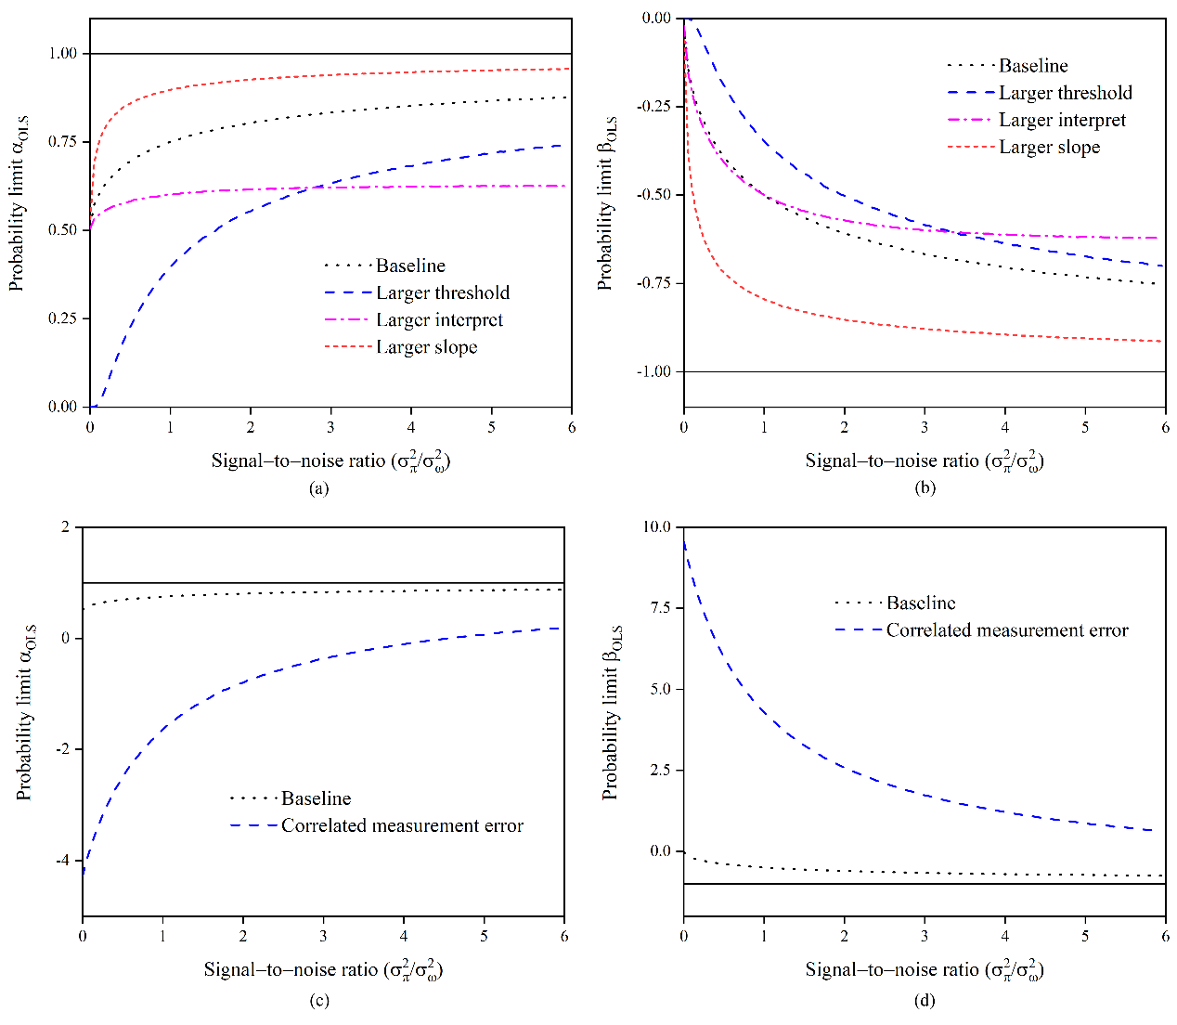

**Figure 2** Simulated probability limit

**3.2 Evidence for the 19th century US and UK**

In Table 2, I estimate the average industrial production growth when price rises (α) and the average negative and positive growth rate when price falls (β, α+β). In the first column, I utilized the CPI from Officer and Williamson (2016), and we can observe that with inflation, the industrial production growth reaches 6.5%. During the deflation periods, we cannot observe significant reduction in the growth rate. The robustness of the growth under deflation is around 4.5%, and this estimation provides an upper bound for our following results, since it is likely that the CPI we utilized in this model contains measurement errors.

With the assumption that the binary indicators with a basis of composite CPI and the proxy being conditionally independent, I provide bounds and points estimates in the second to fourth columns. The drop in industrial production growth becomes more significant (-4.5%) during deflations, and the bound shows that the actual coefficient is

**Table 2** USA industrial production growth during periods of inflation and deflation (1800–1899)

|  |  |  |  |  |  |
| --- | --- | --- | --- | --- | --- |
|  | **Baseline** | **Cond. Independence** | | | **Cond. dependence** |
| **Model parameters:** |  |  |  |  |  |
| *α* = *E*[y|*π* > 0] | 6.510*** | 7.803*** | 7.895*** | 10.245*** | 7.711*** |
|  | (0.957) | (1.158) | (1.175) | (1.969) | (1.302) |
| *β* = *E*[y|*π* < 0] | -2.060 | -4.348** | -4.454*** | -9.682*** | -4.573** |
| – E[y|π > 0] | (1.367) | (1.583) | (1.441) | (3.686) | (2.032) |
| *α* + *β* = *E*[y|*π* < 0] | 4.450** | 3.455* | 3.441* | 0.563 | 3.138 |
|  | (1.669) | (1.961) | (1.859) | (4.179) | (2.413) |
| *P*(*π* < 0) |  |  | 0.591*** |  | 0.415*** |
|  |  |  | (0.201) |  | (0.081) |
| **Bias estimates:** |  |  |  |  |  |
| plim $\hat{α}$– *α* |  |  | -1.549** |  | -1.623* |
|  |  |  | (0.713) |  | (0.839) |
| plim $\hat{β}$– *β* |  |  | 1.506** |  | 1.013* |
|  |  |  | (0.711) |  | (0.511) |
| plim $\hat{α}$ + $\hat{β}$– *α* – *β* |  |  | -0.044 |  | -0.609 |
|  |  |  | (1.007) |  | (1.004) |
| N | 100 | 100 | 100 | 100 | 100 |
| Bound | Upper | Upper | Point | Upper | Point |
| Method | OLS | OLS | GMM | IV | GMM |
| Indicator | CPI | CPI, proxy | CPI, proxy | CPI, proxy | CPI, proxy |

in the range of -4.4% and -9.7%. In the last column, I abnegate the assumption of conditionally independence by assuming that there exists a 15% joint misclassification rate and observe a greater drop in production growth under deflations (-4.6%). It is noticeable that the GMM parameters in the original literature were randomly generated using uniform distribution, so they could not be fully reproduced.

Although the standard errors of different models cannot be compared directly, we can utilize GMM to construct a nonlinear model for estimating the bias of the underlying coefficients. The lower part of Table 2 is the bias estimation of CPI. It can be observed that the drop in real activity is biased by 1.5% significantly with the conditional independence assumption. If we abnegate the assumption, the bias of the growth rate is -1.6% in inflation periods and 1.0% in deflation periods with a 10% significance level. Thus, we can observe that when taking measurement errors into consideration, the relationship between growth and deflation can be statistically different.

However, one noticeable flaw of our analysis is that the data in the USA are scarce in the 19th century, and it put a great emphasis on the agriculture industry. Therefore, I also conduct the analysis for the UK, which provides a more comprehensive and complete data source. Utilizing CPI as the baseline classification and wholesale price index as a proxy, we can observe the relationship of growth in different real activity measurements with inflations and deflations in Table 3.

**Table 3** Change in UK economic activity during periods of deflation (1830–1899)

|  |  |  |  |  |  |
| --- | --- | --- | --- | --- | --- |
|  | **Baseline** | **Cond. Independence** | | | **Cond. dependence** |
| GDP growth | -1.092* | -1.611** | -1.882 | -2.702* | -2.886 |
| (0.578) | (0.694) | (1.432) | (1.549) | (2.162) |
| Industrial production growth | -2.651 | -4.284 | -4.644 | -7.667 | -5.132 |
| (2.256) | (2.728) | (3.086) | (5.933) | (3.193) |
| Unemployment rate | 2.044*** | 2.270*** | 2.379** | 3.086** | 4.704** |
| (0.477) | (0.565) | (1.065) | (1.254) | (1.977) |
| Consumption growth | -1.051** | -1.401** | -2.202 | -2.235* | -2.308 |
| (0.439) | (0.533) | (3.690) | (1.174) | (1.947) |
| Investment growth | -7.153** | -10.578*** | -11.159 | -18.431** | -14.177 |
| (3.002) | (3.598) | (10.437) | (8.382) | (11.266) |
| N | 70 | 70 | 70 | 70 | 70 |
| Bound | Upper | Upper | Point | Upper | Point |
| Method | OLS | OLS | GMM | IV | GMM |
| Indicator | CPI | CPI, proxy | CPI, proxy | CPI, proxy | CPI, proxy |

Under deflation, we can observe an increase in the unemployment rate, and a decrease in the industrial production, growth of consumption, and investments. It is worth emphasizing that when we exploit a second deflation indicator, the estimate grows larger, which indicates that we can also find misclassification bias in the data of the UK.

**3.3 Evidence from Simulations**

To investigate whether we can assume there exists measurement errors when analyzing the relationship of GDP growth and deflations, we construct two simulations. First, to simulate the nominal GDP deflated by an error-ridden CPI, an error ridden GDP measure is constructed for the 19th century in the US (see, e.g., Studer & Schuppli, 2008; Kaufmann, 2019; HSSO, 2012, for Switzerland). Second, to mimic the volatility in measurement errors, inflations, and GDP growth, a data calibration is simulated by replicating the result with modern US data. The results of simulation cannot be fully reproduced since the error terms are randomly generated under normal distribution by STATA.

From the result shown in Table 4, we can see that the results remain unchanged if we take US CPI as a deflator, and we can observe a significantly positive relationship between the real GDP growth and the deflations if we take the proxy as a deflator.

These results can be furtherly proved with the simulation exercises. It can be observed that the i.i.d. measurement errors in GDP growth will cause the standard errors to increase with $α=3$ and $β=-1$. If we utilize the error-ridden indicator when deflating the nominal GDP with high data accuracy, the sign of the coefficients will turn to the opposite.

**Table 4** The role of the GDP deflator

|  |  |  |  |  |  |
| --- | --- | --- | --- | --- | --- |
|  | **Baseline** | **Cond. Independence** | | | **Cond. dependence** |
| **US NGDP/CPI:** |  |  |  |  |  |
| *α* = *E*[y|*π* > 0] | 4.965*** | 5.545*** | 7.627 | 6.612*** | 10.467** |
|  | (0.543) | (0.668) | (6.892) | (1.064) | (4.082) |
| *β* = *E*[y|*π* < 0] | -1.252 | -2.262** | -4.388 | -4.613** | -7.769* |
| – *E*[y|*π* > 0] | (0.776) | (0.913) | (8.398) | (1.991) | (4.569) |
| **US NGDP/Proxy:** |  |  |  |  |  |
| *α* = *E*[y|*π* > 0] | 5.412*** | 1.760* | 1.025 | -3.149 | 1.541 |
|  | (0.990) | (1.001) | (0.771) | (2.839) | (1.027) |
| *β* = *E*[y|*π* < 0] | -1.048 | 4.288*** | 5.304*** | 16.424*** | 4.448** |
| – *E*[y|*π* > 0] | (1.414) | (1.368) | (1.346) | (5.315) | (1.995) |
| **Simualtion:** |  |  |  |  |  |
| *α* = *E*[y|*π* > 0] | 2.674*** | 2.770*** | 3.839 | 3.290*** | 3.645*** |
|  | (0.095) | (0.119) | (2.383) | (0.250) | (0.939) |
| *β* = *E*[y|*π* < 0] | -0.368*** | -0.622*** | -1.691 | -1.509*** | -1.447 |
| – *E*[y|*π* > 0] | (0.129) | (0.160) | (2.719) | (0.447) | (1.054) |
| **Simualtion GDP + i.i.d. error:** | |  |  |  |  |
| *α* = *E*[y|*π* > 0] | 2.088*** | 2.149*** | 3.837** | 2.788*** | 1.939** |
|  | (0.171) | (0.216) | (1.666) | (1.666) | (0.883) |
| *β* = *E*[y|*π* < 0] | 0.012 | -0.267 | -1.778 | -1.284 | 0.066 |
| – *E*[y|*π* > 0] | (0.233) | (0.289) | (1.849) | (0.788) | (0.994) |
| **Simualtion NGDP/Proxy:** |  |  |  |  |  |
| *α* = *E*[y|*π* > 0] | 1.025*** | 1.565*** | 1.408*** | 3.641*** | 0.120 |
|  | (0.160) | (0.197) | (0.209) | (0.497) | (0.379) |
| *β* = *E*[y|*π* < 0] | 3.206*** | 2.100*** | 2.292*** | -1.639* | 3.961*** |
| – *E*[y|*π* > 0] | (0.217) | (0.264) | (0.259) | (0.887) | (0.490) |
| Bound | Upper | Upper | Point | Upper | Point |
| Method | OLS | OLS | GMM | IV | GMM |
| Indicator | CPI | CPI, proxy | CPI, proxy | CPI, proxy | CPI, proxy |

**4 Conclusion**

In the past research, it has been displayed that there is little evidence showing that deflation can have a negative effect on economic growth, and it has been suggested by the previous research that this may show that deflation episodes are more benign than the intuition. This essay suggests a potential reason for the unobserved link between real economics activities growth and deflations, which is the existing measurement errors in the price indices. This essay uses two novel models to prove that deflations are more costly than the previous empirical studies suggested, and it put an emphasis on the 19th century data in the US and UK. However, it is still a remaining question whether these measurement errors can affect the structural analysis and in turn lead to flawed decisions made by contemporary policy makers, and whether the conclusions we made can be extended to countries other than the US and UK. Therefore, more quantitative and comprehensive evaluations are still in need for further research about the impact of deflations on the world economy.

**Reference**

Kaufmann D. Is deflation costly after all? The perils of erroneous historical classifica-tions. J Appl Econ. 2020;35:614–628. https://doi.org/10.1002/jae.2762

Aghion, P., Bergeaud, A., Boppart, T., Klenow, P. J., & Li, H. (2019). Missing growth from creative destruction. American Economic Review, 109(8), 2795–2822.

Aigner, D. J. (1973). Regression with a binary independent variable subject to errors of observation. Journal of Econometrics, 1, 49–60.

Atkeson, A., & Kehoe, P. J. (2004). Deflation and depression: Is there an empirical link? American Economic Review, 94(2), 99–103.

Bordo, M. D., & Filardo, A. (2005). Deflation and monetary policy in a historical perspective: Remembering the past or being condemned to repeat it? Economic Policy, 20(44), 799–844.

Bordo, M. D., & Redish, A. (2004). Is deflation depressing? Evidence from the classical Gold Standard. In Burdekin, R. C. K, & Siklos, P. L. (Eds.), Deflation: Current and Historical Perspectives (pp. 99–202). Cambridge: Cambridge University Press.

Boskin Commission (1996). Toward a more accurate measure of the cost of living: Final report to the Senate Finance Committee from the Advisory Committee to study the consumer price index. Retrieved from www.ssa.gov/history/reports/boskinrpt.html

Cogley, T., & Sargent, T. J. (2015). Measuring price-level uncertainty and instability in the United States, 1850-2012. The Review of Economics and Statistics, 97(4), 827–838.

Davis, J. H. (2004). An annual index of US industrial production, 1790-1915. The Quarterly Journal of Economics, 119(4), 1177–1215.

Goolsbee, A. D., & Klenow, P. J. (2018). Internet rising, prices falling: Measuring inflation in a world of e-commerce. AEA Papers and Proceedings, 108, 488–92.

HSSO (2012). Nationale Buchhaltung: Tab. Q.1a., Historische Statistik der Schweiz. Retrieved from www.hsso.ch/2012/q/

Hoover, E. D. (1958). Wholesale and retail prices in the nineteenth century. The Journal of Economic History, 18(03), 298–316.

Hoover, E. D. (1960). Retail prices after 1850, Trends in the American economy in the nineteenth century (pp. 141–190). Princeton, NJ: Princeton University Press.

Kaufmann, D. (2019). Nominal stability over two centuries. Swiss Journal of Economics and Statistics, 155, 1–23.

Margo, R. A. (2000). Wages and labor markets in the United States, 1820-1860. Chicago: University of Chicago Press.

Officer, L. H. (2014). What was the consumer price index then? A data study. Note, MeasuringWorth, retrieved from www.measuringworth. com/docs/cpistudyrev.pdf

Officer, L. H., & Williamson, S. H. (2016). Annual consumer price index for the United States, 1774-2015 Note, MeasuringWorth, retrieved from www.measuringworth.com/uscpi/

Studer, R., & Schuppli, P. (2008). Deflating Swiss prices over the past five centuries. Historical Methods, 41(3), 137–153.

**Appendix**

Table A.1 Data sources

|  |  |  |  |
| --- | --- | --- | --- |
| Name | Time | Identifier | Comments |
| **United States** |  |  |  |
| CPI | 1774-2018 | Officer and Williamson (2016) |
| Real GDP | 1790-2018 |  | Johnston and Williamson (2016); |
|  |  |  | per capita series available |
| Industrial production | 1790-1915 |  | Davis (2004) |
|  | 1899-1937 | Dd495 | Atack and Bateman (2006) linked with |
|  |  |  | Fabricant (1940) |
|  | 1919-2015 | INDPRO | fred.stlouisfed.org |
| Banking crises | 1825-1929 |  | Jalil (2015); 1833-1834, 1837-1839, |
|  |  |  | 1857, 1873,1893, 1907 |
| Stock prices | 1802-1870 | Cj797 | Rousseau (2006); index of common stocks |
|  | 1870-2015 |  | Jorda` et al. (2016) and Knoll et al. (2017) |
| Money supply | 1867-1947 |  | M2 by Friedman and Schwartz (1963) as |
|  |  |  | reported by Anderson (2003) |
| **United Kingdom** |  |  | Hills et al. (2019) |
| Real GDP per capita | 1800-2016 | A1-B | Longer series available |
| Total production and | 1800-1913 | A14-Q | Longer series available |
| construction |  |  |  |
| Private consumption | 1830-2016 | A1-P |  |
| Investment | 1830-2016 | A1-Q |  |
| Unemployment rate | 1759-2016 | A1-AB |  |
| CPI | 1800-2016 | A1-AO | Used for baseline |
| WPI | 1830-2016 | A47-J | Used as proxy |